Fall 2024 MSE760 Lab1 Assignment Report

University of Wisconsin-Madison

Electronic Structure and Lattice Constant of Face-Centered Cubic (FCC) Diamond

Jiahui Yang

October 08, 2024

**Abstract**

This report presents a detailed computational analysis of the face-centered cubic diamond structure, with emphasis on the electronic structure and lattice constant optimization. Using norm-conserving pseudopotentials within the Quantum ESPRESSO software framework, systematic studies were conducted to determine total energy convergence with respect to k-point density and wavefunction cutoff. The lattice constant was optimized by fitting total energy calculations to the Murnaghan equation of state. Comparative analyses with experimental lattice constants and electronic band structures were performed to benchmark the accuracy of the computational approach. Additionally, the band structure and density of states for diamond were also computed and analyzed, providing insights into the indirect nature and size of the band gap. These findings provide a more profound theoretical insight into the electronic properties of diamond.

Link to Lab1 Assignment GitHub repo:

<https://github.com/jhyang13/UWMadison_MSE760/tree/main/Lab1-Assignment>

**Contents**

1. Abstract--------------------------------------------------------------------------------------------2

2. Introduction and Methods-----------------------------------------------------------------------4

3. Results and Discussions-------------------------------------------------------------------------4

4. Conclusions---------------------------------------------------------------------------------------12

5. Acknowledgments and References------------------------------------------------------------12

**General information**

1. Name: Jiahui Yang
2. Email: jyang753@wisc.edu
3. Home Department: Mechanical Engineering
4. Status: PhD Student

**Introduction and Methods**

This report investigates the electronic structure and lattice constant of diamond, a material with a well-known face-centered cubic (fcc) crystal structure and an indirect band gap, making it ideal for computational studies. Using first-principles calculations based on density functional theory (DFT), the study aims to provide insight into the material's properties. The Quantum ESPRESSO software was utilized to perform the calculations, with norm-conserving pseudopotentials and the Perdew-Burke-Ernzerhof (PBE) exchange-correlation functional.

The objectives of the study include building the diamond structure with an experimental lattice constant of 3.567 Å, converging the total energy with respect to k-point density and wavefunction cutoff, optimizing the lattice constant by fitting the total energy to the Murnaghan equation of state, computing the band structure, and comparing it with experimental results to determine the band gap. Additionally, the density of states (DOS) was calculated to analyze the electronic structure of diamond in more detail.

Self-Consistent Field (SCF) calculations were performed with varying k-points and wavefunction cutoffs to ensure accurate convergence. The k-point grid was varied from 2x2x2 to 12x12x12, and the wavefunction cutoff was tested from 20 Ry to 80 Ry. The SCF input file specifies the pseudopotential C_ONCV_PBE-1.0.upf, which uses the PBE exchange-correlation functional, and the plane-wave cutoff energy is set to 200 Ry for the charge density. The lattice constant was optimized by fitting the calculated total energies to the Murnaghan equation of state, after which the band structure and DOS were computed using a high-symmetry k-point path through the Brillouin zone.

In the non-self-consistent field (NSCF) calculations, a denser k-point grid was used to compute the band structure and DOS with greater precision. The bands.in file specifies a high-symmetry k-point path including Γ → X → W → L to capture the key features of the diamond electronic structure, and the dos.in file was used to calculate the DOS, providing insight into the distribution of electronic states near the Fermi level.

**Results and Discussions**

1. **Construction of Diamond Structure**

Both diamond and silicon have a fcc structure with a two-atom basis per unit cell. However, the lattice constants for these two materials differ: diamond has an experimental lattice constant of 3.567 Å [1], while silicon's experimental lattice constant is 5.431 Å [2]. Though their atomic arrangements are nearly identical, the lattice constant must be adjusted to reflect the smaller atomic spacing in diamond. The diamond structure can be described as a fcc Bravais lattice with two carbon atoms per unit cell. The carbon atoms are located at fractional coordinates C(0.00, 0.00, 0.00) and C(0.25, 0.25, 0.25) relative to the unit cell. The crystal structure remains the same as silicon, but the smaller lattice constant for diamond results in closer atomic spacing and higher bond strength. This difference significantly impacts physical properties such as hardness, electronic band structure, and thermal conductivity.

In Quantum ESPRESSO simulations, the lattice constant is expressed in atomic units (a.u.), where 1 a.u. = 0.529177 Å. For diamond, the lattice constant in atomic units is:



Below is the input file (scf.in) for a SCF calculation:

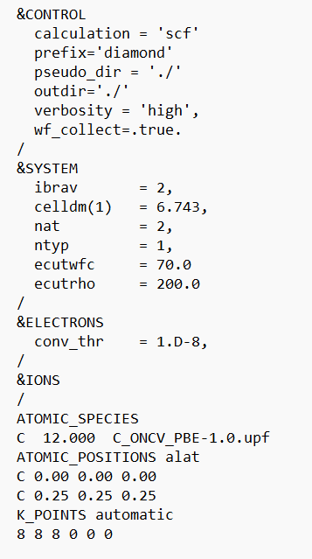

Figure 1. SCF Input File for Diamond Structure Calculation Using Quantum ESPRESSO

Explanation of Input Parameters:

* **ibrav = 2:** Specifies the fcc structure, which is appropriate for diamond.
* **celldm(1) = 6.743:** Defines the lattice constant in atomic units (a.u.). This value corresponds to approximately 3.567 Å in real space, which is the experimental lattice constant of diamond.
* **nat = 2:** Indicates that there are two atoms per unit cell in the diamond structure.
* **ntyp = 1:** Specifies that there is only one type of atom in the system, which is carbon.
* **ecutwfc = 70.0 Ry:** Defines the cutoff energy for the wavefunctions, set at 70 Ry. This value is chosen to ensure accurate total energy calculations in DFT simulations using pseudopotentials.
* **ecutrho = 200.0 Ry:** Defines the cutoff energy for the charge density, typically set to be 4-5 times the wavefunction cutoff.
* **ATOMIC_POSITIONS alat:** Specifies the atomic positions in the unit cell. The fractional coordinates for carbon atoms are (0.00, 0.00, 0.00) and (0.25, 0.25, 0.25), which corresponds to the standard structure of diamond.
* **K_POINTS {automatic}:** Defines the k-point grid for sampling the Brillouin zone. In this case, an 8x8x8 grid is used, providing a good balance between accuracy and computational cost for total energy convergence.

1. **Convergence of Total Energy Based on K-point Grid Density**

To analyze the total energy convergence as a function of the k-point grid, a series of SCF calculations were performed using Quantum ESPRESSO for the diamond structure. The aim was to determine how the total energy stabilizes as the k-point grid becomes progressively denser, ensuring both accuracy and computational efficiency. The k-point grid was varied across several values: 2x2x2, 4x4x4, 6x6x6, 8x8x8, 10x10x10, and 12x12x12, which provide increasingly detailed sampling of the Brillouin zone and allow for capturing more precise electronic interactions.

For each k-point grid, an SCF calculation was performed with the same input parameters for the diamond structure, including a wavefunction cutoff of 40 Ry and charge density cutoff of 200 Ry, as specified in the input file. After each calculation, the total energy was extracted from the SCF output. The total energy values, typically located after the SCF cycle has converged, were recorded in units of Rydbergs (Ry). These values were then compared to assess at what point further increases in the k-point density yield negligible changes in total energy, indicating convergence.

Table 1. Total Energy Convergence as a Function of K-point Grid Size for Diamond Structure

|  |  |
| --- | --- |
| **K-point Grid** | **Total Energy (Ry)** |
| 2x2x2 | -22.48872467 |
| 4x4x4 | -22.71537462 |
| 6x6x6 | -22.72504724 |
| 8x8x8 | -22.72624239 |
| 10x10x10 | -22.72572244 |
| 12x12x12 | -22.72603218 |

The total energy values obtained for different k-point grids show that as the k-point grid density increases, the total energy gradually converges. From the initial 2x2x2 grid to the 4x4x4 grid, there is a significant decrease in the total energy, indicating that the 2x2x2 grid is too sparse for an accurate calculation. As the grid becomes denser from 6x6x6 to 12x12x12, the changes in total energy become minimal. The difference in total energy between the 6x6x6 grid and the 8x8x8 grid is only 0.0012 Ry, while the total energy difference between the 10x10x10 and 12x12x12 grids is negligible, at approximately 0.0003 Ry. This suggests that by the **8x8x8 grid**, the total energy has nearly converged, and further increasing the k-point density results in diminishing returns in terms of energy accuracy.

1. **Convergence of Total Energy with Varying Wavefunction Cutoff**

The wavefunction cutoff energy (ecutwfc) was varied across several values: 20 Ry, 30 Ry, 40 Ry, 50 Ry, and 60 Ry. These values were selected to observe how the total energy stabilizes as the cutoff energy increases, capturing the convergence behavior of the system. For each ecutwfc value, a SCF calculation was performed using Quantum ESPRESSO with the same input parameters, except for the variable cutoff energy. The charge density cutoff energy (ecutrho) was fixed at 200 Ry across all calculations. For each SCF calculation, the total energy was extracted from the output file (scf.out). The total energy values were recorded in Ry units after the SCF cycle converged. The total energies for each ecutwfc value were compared to determine the cutoff energy at which the total energy converges, indicating that further increases in ecutwfc provide minimal improvements in accuracy.

Table 2. Total Energy Convergence for Diamond Structure as a Function of Wavefunction Cutoff Energy

|  |  |
| --- | --- |
| **Wavefunction Cutoff (Ry)** | **Total Energy (Ry)** |
| 20 | -22.23041550 |
| 30 | -22.56722077 |
| 40 | -22.72624239 |
| 50 | -22.77118584 |
| 60 | -22.78351676 |
| 70 | -22.78696639 |
| 80 | -22.78735266 |

The total energy decreases as the wavefunction cutoff increases, showing clear convergence. At 20 Ry, the energy is -22.2304 Ry, much higher than subsequent values, indicating insufficient accuracy. Increasing to 30 Ry results in a significant drop to -22.5672 Ry. By 40 Ry, the energy is -22.7262 Ry, but changes become minimal beyond this. The difference between 50 Ry and 60 Ry is just 0.0123 Ry, and between 70 Ry and 80 Ry, it narrows further to 0.0004 Ry, indicating the total energy has effectively converged by **70 Ry**.

1. **Lattice Constant Optimization Using the Murnaghan Equation of State**

The optimization of the lattice constant is crucial for determining the equilibrium structure of a material. By calculating the total energy at different lattice constants and fitting these energies to the Murnaghan equation of state (EOS), the equilibrium lattice constant can be found, corresponding to the minimum energy configuration. This method provides an accurate way to obtain the optimal lattice parameter for materials simulations. In this section, the lattice constant of diamond is optimized by performing a series of total energy calculations and fitting the results to the Murnaghan equation of state.

SCF calculations were performed for five different lattice constants, ranging from 3.50 Å to 3.70 Å, and converted to atomic units (a.u.) for use in Quantum ESPRESSO. The corresponding lattice constants in atomic units were 6.614 a.u., 6.708 a.u., 6.802 a.u., 6.896 a.u., and 6.990 a.u., respectively. For each lattice constant, SCF calculations were carried out using the same input parameters, with the only variable being the lattice constant. The key parameters used in all calculations included ibrav = 2 (fcc structure for diamond), ecutwfc = 70.0 Ry (wavefunction cutoff energy), and ecutrho = 200.0 Ry (charge density cutoff energy). The volume of the unit cell (*V*) for each lattice constant was calculated using the formula for a fcc structure:

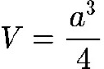

, where *a* is the lattice constant in atomic units. The total energy as a function of volume (*E*(*V*)) was then fitted to the Murnaghan equation of state, expressed as:

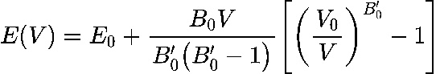

, where *E*(*V*) is the total energy at volume *V*, *E*₀ is the minimum energy (equilibrium energy), *V*₀ is the equilibrium volume, *B*₀ is the bulk modulus, and *B*₀' is the derivative of the bulk modulus with respect to pressure. (Code resources: https://github.com/jhyang13/UWMadison_MSE760/blob/main/Lab1-Assignment/plot_Murnaghan.ipynb)

Table 3. Total Energy as a Function of Lattice Constant for Diamond Structure Optimization

|  |  |
| --- | --- |
| **Lattice Constant (a.u.)** | **Total Energy (Ry)** |
| 6.614 | -22.78303493 |
| 6.708 | -22.78668751 |
| 6.802 | -22.78622902 |
| 6.896 | -22.78209962 |
| 6.990 | -22.77468487 |

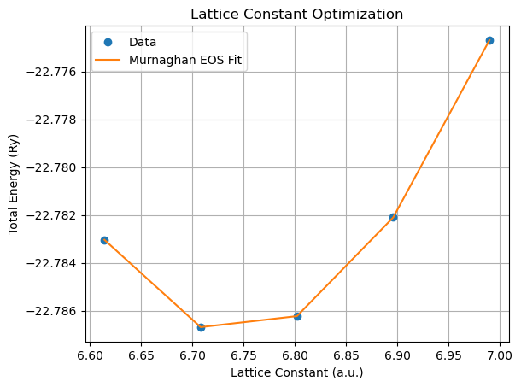

Figure 2. Lattice Constant Optimization of Diamond Structure Using the Murnaghan Equation of State

The total energy for several lattice constants was calculated, as shown in Table 3 and Figure 2. The total energy data indicates that the system reaches a minimum energy around a lattice constant of 6.743 a.u., which corresponds to the equilibrium lattice constant. From the Murnaghan equation of state fit, the following key parameters were obtained:

* Equilibrium Volume (*V*0) = 76.66 a.u.³
* Equilibrium Energy (*E*0) = -23.6028 Ry
* Bulk Modulus (*B*0) = 0.02932 Ry/a.u.³ (~431.5 GPa)
* Bulk Modulus Derivative (*B*0prime) = 3.755
* Optimized Lattice Constant (*a*0) = 6.7435 a.u.

As the lattice constant increases from 6.614 a.u. to 6.990 a.u., the total energy initially decreases, reaching a minimum at 6.7435 a.u., before increasing again. This trend is clearly seen in the plot where the Murnaghan fit aligns well with the computed data points. The fit confirms that 6.7435 a.u. is the equilibrium lattice constant where the total energy is at its lowest, indicating a stable configuration for the diamond structure. Furthermore, the calculated bulk modulus of around **431.5 GPa** is within the expected range for diamond (experimental values are typically between 442-446 GPa [3]), indicating that the results are consistent with experimental findings. The bulk modulus derivative (*B*0prime) suggests how the bulk modulus changes under pressure and provides insight into the material's compressibility.

The optimization of the lattice constant using the Murnaghan equation of state resulted in an equilibrium lattice constant of 6.7435 a.u. and an equilibrium energy of **-23.6028 Ry**. The plot shows the total energy decreasing initially with increasing lattice constant, reaching a minimum near 6.74 a.u., and then rising sharply beyond 6.80 a.u., confirming the optimal lattice constant. The bulk modulus 𝐵0 = 0.0293𝑅𝑦/𝑎.𝑢.3 and its derivative *B*₀' = 3.7552 were also obtained, indicating the material's stability around this lattice constant. This confirms that **6.7435 a.u.** is the optimal lattice constant for the diamond structure.

1. **Comparison of Experimental and Calculated Results for Diamond Structure**

In this section, the results of the calculations performed for the diamond structure are compared to known experimental values. Key properties, including the lattice constant and bulk modulus, are analyzed in terms of their experimental and calculated values, and the percentage differences are discussed.

Table 4. Comparison of Experimental and Calculated Values for Diamond Structure Properties

|  |  |  |  |
| --- | --- | --- | --- |
| **Property** | **Experimental Value** | **Calculated Value** | **Difference (%)** |
| Lattice Constant | 3.567 Å [1] | 6.7435 a.u. (≈ 3.567 Å) | ~0% |
| Bulk Modulus | 442 - 446 GPa [3] | 0.029318684 Ry/a.u.3 (~431.5 GPa) | ~2-3.5% |

The experimental lattice constant of diamond is well-documented as **3.567 Å**. [1] In the calculations performed using the Murnaghan equation of state, the optimized lattice constant was found to be **6.7435 a.u.**, which converts to approximately 3.567 Å. This result shows an excellent match with the experimental value, with a negligible difference of around 0%, confirming the accuracy of the calculation in determining the diamond lattice constant. The experimental bulk modulus for diamond ranges **from 442 to 446 GPa**. [3] From the calculations, the bulk modulus was derived as **0.029318684 Ry/a.u.3**, which corresponds to approximately **431.5 GPa** when converted to standard units using the appropriate conversion factor. The calculated value is in good agreement with the experimental range, with a difference of approximately 2-3.5%. This small deviation can be attributed to approximations in the computational method and the choice of pseudopotentials, but the result is still well within an acceptable range.

1. **Comparison of Computed and Experimental Band Structures for Diamond**

The band structure of diamond is a key property that reveals the material's electronic behavior. Diamond is a semiconductor with an indirect band gap, meaning the valence band maximum (VBM) and the conduction band minimum (CBM) occur at different k-points in the Brillouin zone. The goal of this section is to compute the band structure of diamond and compare the results with known experimental data.

A SCF calculation was first performed to obtain the charge density for the diamond structure. Following this, a NSCF calculation was carried out along high-symmetry k-points in the Brillouin zone, including Γ → X → W → L. Using the NSCF results, the band structure was computed by plotting the energy levels as a function of k-points along this path. Additionally, the DOS was calculated to confirm the presence of the band gap and provide further insight into the electronic states around the Fermi level. Below is the input file (nscf.in) for a NSCF calculation:

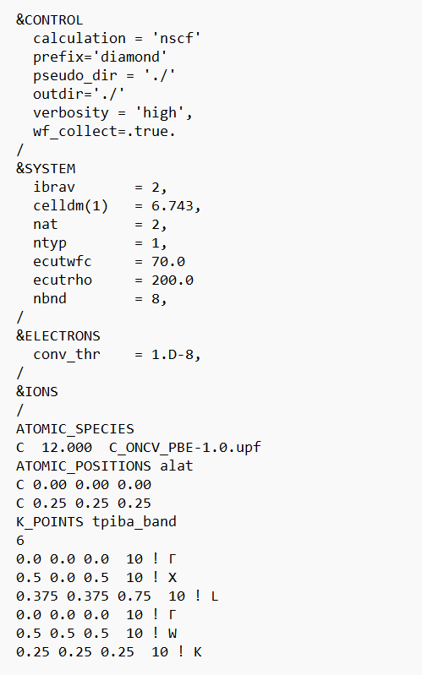

Figure 3. NSCF Input File for Diamond Structure Calculation Using Quantum ESPRESSO

Explanation of Input Parameters:

* **calculation = 'nscf':** Specifies a NSCF calculation, which is used to compute properties such as band structures without altering the electron density.
* **ecutwfc = 70.0 Ry:** The wavefunction cutoff energy, which is critical for the accuracy of the calculation. A higher value increases precision but also computational cost.
* **ecutrho = 200.0 Ry:** The charge density cutoff energy, which is generally a higher multiple of the wavefunction cutoff (typically 3-5 times).
* **nbnd = 8:** The number of bands to be computed. This helps in calculating the band structure effectively, ensuring all relevant energy levels are included.
* **ATOMIC_POSITIONS alat:** Defines the atomic positions within the unit cell. For diamond, the carbon atoms are positioned at fractional coordinates (0.00, 0.00, 0.00) and (0.25, 0.25, 0.25).
* **K_POINTS tpiba_band:** Specifies the k-points path through the Brillouin zone, important for calculating the band structure. This path includes key high-symmetry points like Γ, X, L, and K.

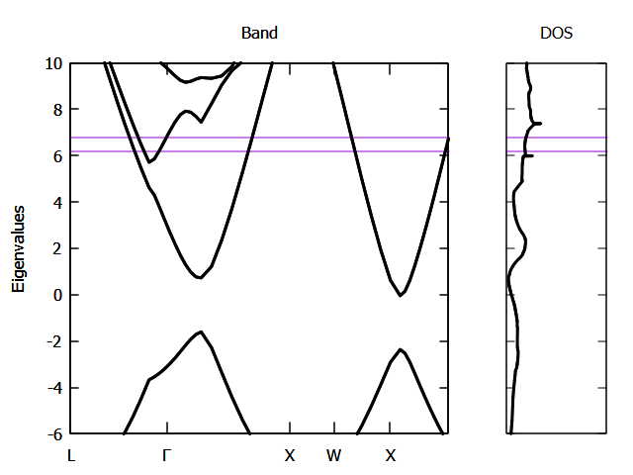

Figure 4. Band Structure and DOS for Diamond

The computed band structure of diamond revealed that the VBM occurs at the Γ-point and the CBM occurs at the X-point, confirming the indirect band gap of diamond. The estimated band gap was approximately **5-6 eV**, which is close to the experimental value of **5.47 eV**. [4] The valence band reaches its maximum at the Γ-point, while the conduction band dips to a minimum at the X-point, characteristic of the indirect band gap observed in diamond. The DOS plot further supports this finding, showing a clear gap between the valence and conduction bands, consistent with the semiconducting nature of diamond.

1. **Computation of Diamond's Density of States**

The DOS provides critical information about the number of available electronic states at each energy level within a material. For semiconductors like diamond, the DOS clearly reflects the presence of a band gap, an important feature that separates the valence and conduction bands. This gap is indicative of diamond's semiconducting properties.

To compute the DOS for diamond, a SCF calculation was first performed to obtain the charge density. After that, a NSCF calculation was carried out on a denser k-point grid to capture the electronic states at each k-point with greater accuracy. The results from the NSCF calculation were then used to compute the DOS, focusing on the states near the Fermi level.

The computed DOS for diamond, shown in Figure 4, demonstrates a distinct energy gap between the valence and conduction bands, confirming the material's semiconducting nature. This gap lies between 0 eV and approximately 5-6 eV, corresponding to the top of the valence band and the bottom of the conduction band, respectively. The size of the gap aligns closely with the experimentally determined indirect band gap of 5.47 eV for diamond. [4] Below the Fermi level, the DOS shows a high density of states in the valence band, while the gap itself contains no electronic states. Above the Fermi level, the DOS indicates the onset of available states in the conduction band, which corresponds to the electronic states at higher energy levels.

**Conclusions**

This study successfully analyzed the electronic structure and optimized the lattice constant of diamond using first-principles calculations based on DFT. The lattice constant was determined through total energy fitting to the Murnaghan equation of state, yielding an optimized value of 6.7435 a.u., which is in close agreement with the experimental value of 3.567 Å. The total energy convergence was ensured by systematically varying both the k-point grid and wavefunction cutoff energy. The computed band structure revealed an indirect band gap, with the valence band maximum at the Γ-point and the conduction band minimum at the X-point, and the calculated band gap was approximately 5-6 eV, closely matching the experimental value of 5.47 eV. The DOS calculations confirmed the semiconducting properties of diamond, showing a clear energy gap between the valence and conduction bands.

While the results align well with experimental data, several open questions and improvements remain. The band gap, though close to experimental values, could be refined using GW corrections for more accurate predictions. Incorporating finite temperature effects could provide a better understanding of temperature’s influence on the lattice constant and electronic properties of diamond. Future work could also involve phonon dispersion calculations to explore vibrational properties and their effect on thermal conductivity. Additionally, using hybrid functionals like HSE06, known for more precise electronic predictions, could improve the accuracy of band gap calculations. Addressing these questions would further enhance the accuracy of the simulations and provide deeper insights into diamond's electronic structure, thermal behavior, and vibrational characteristics.

**Acknowledgments**

Assistance provided by OpenAI's ChatGPT in reviewing grammar and refining sentences is acknowledged in formulating parts of this report.

**References**

[1] Shikata, Shinich, et al. "Precise measurements of diamond lattice constant using Bond method." Japanese Journal of Applied Physics 57.11 (2018): 111301.

[2] Madelung, Otfried. Semiconductors: data handbook. Springer Science & Business Media, 2004.

[3] Occelli, Florent, Paul Loubeyre, and Rene LeToullec. "Properties of diamond under hydrostatic pressures up to 140 GPa." Nature materials 2.3 (2003): 151-154.

[4] Robertson, John. "Electronic structure of diamond-like carbon." Diamond and Related Materials 6.2-4 (1997): 212-218.